**Curriculum Vita**

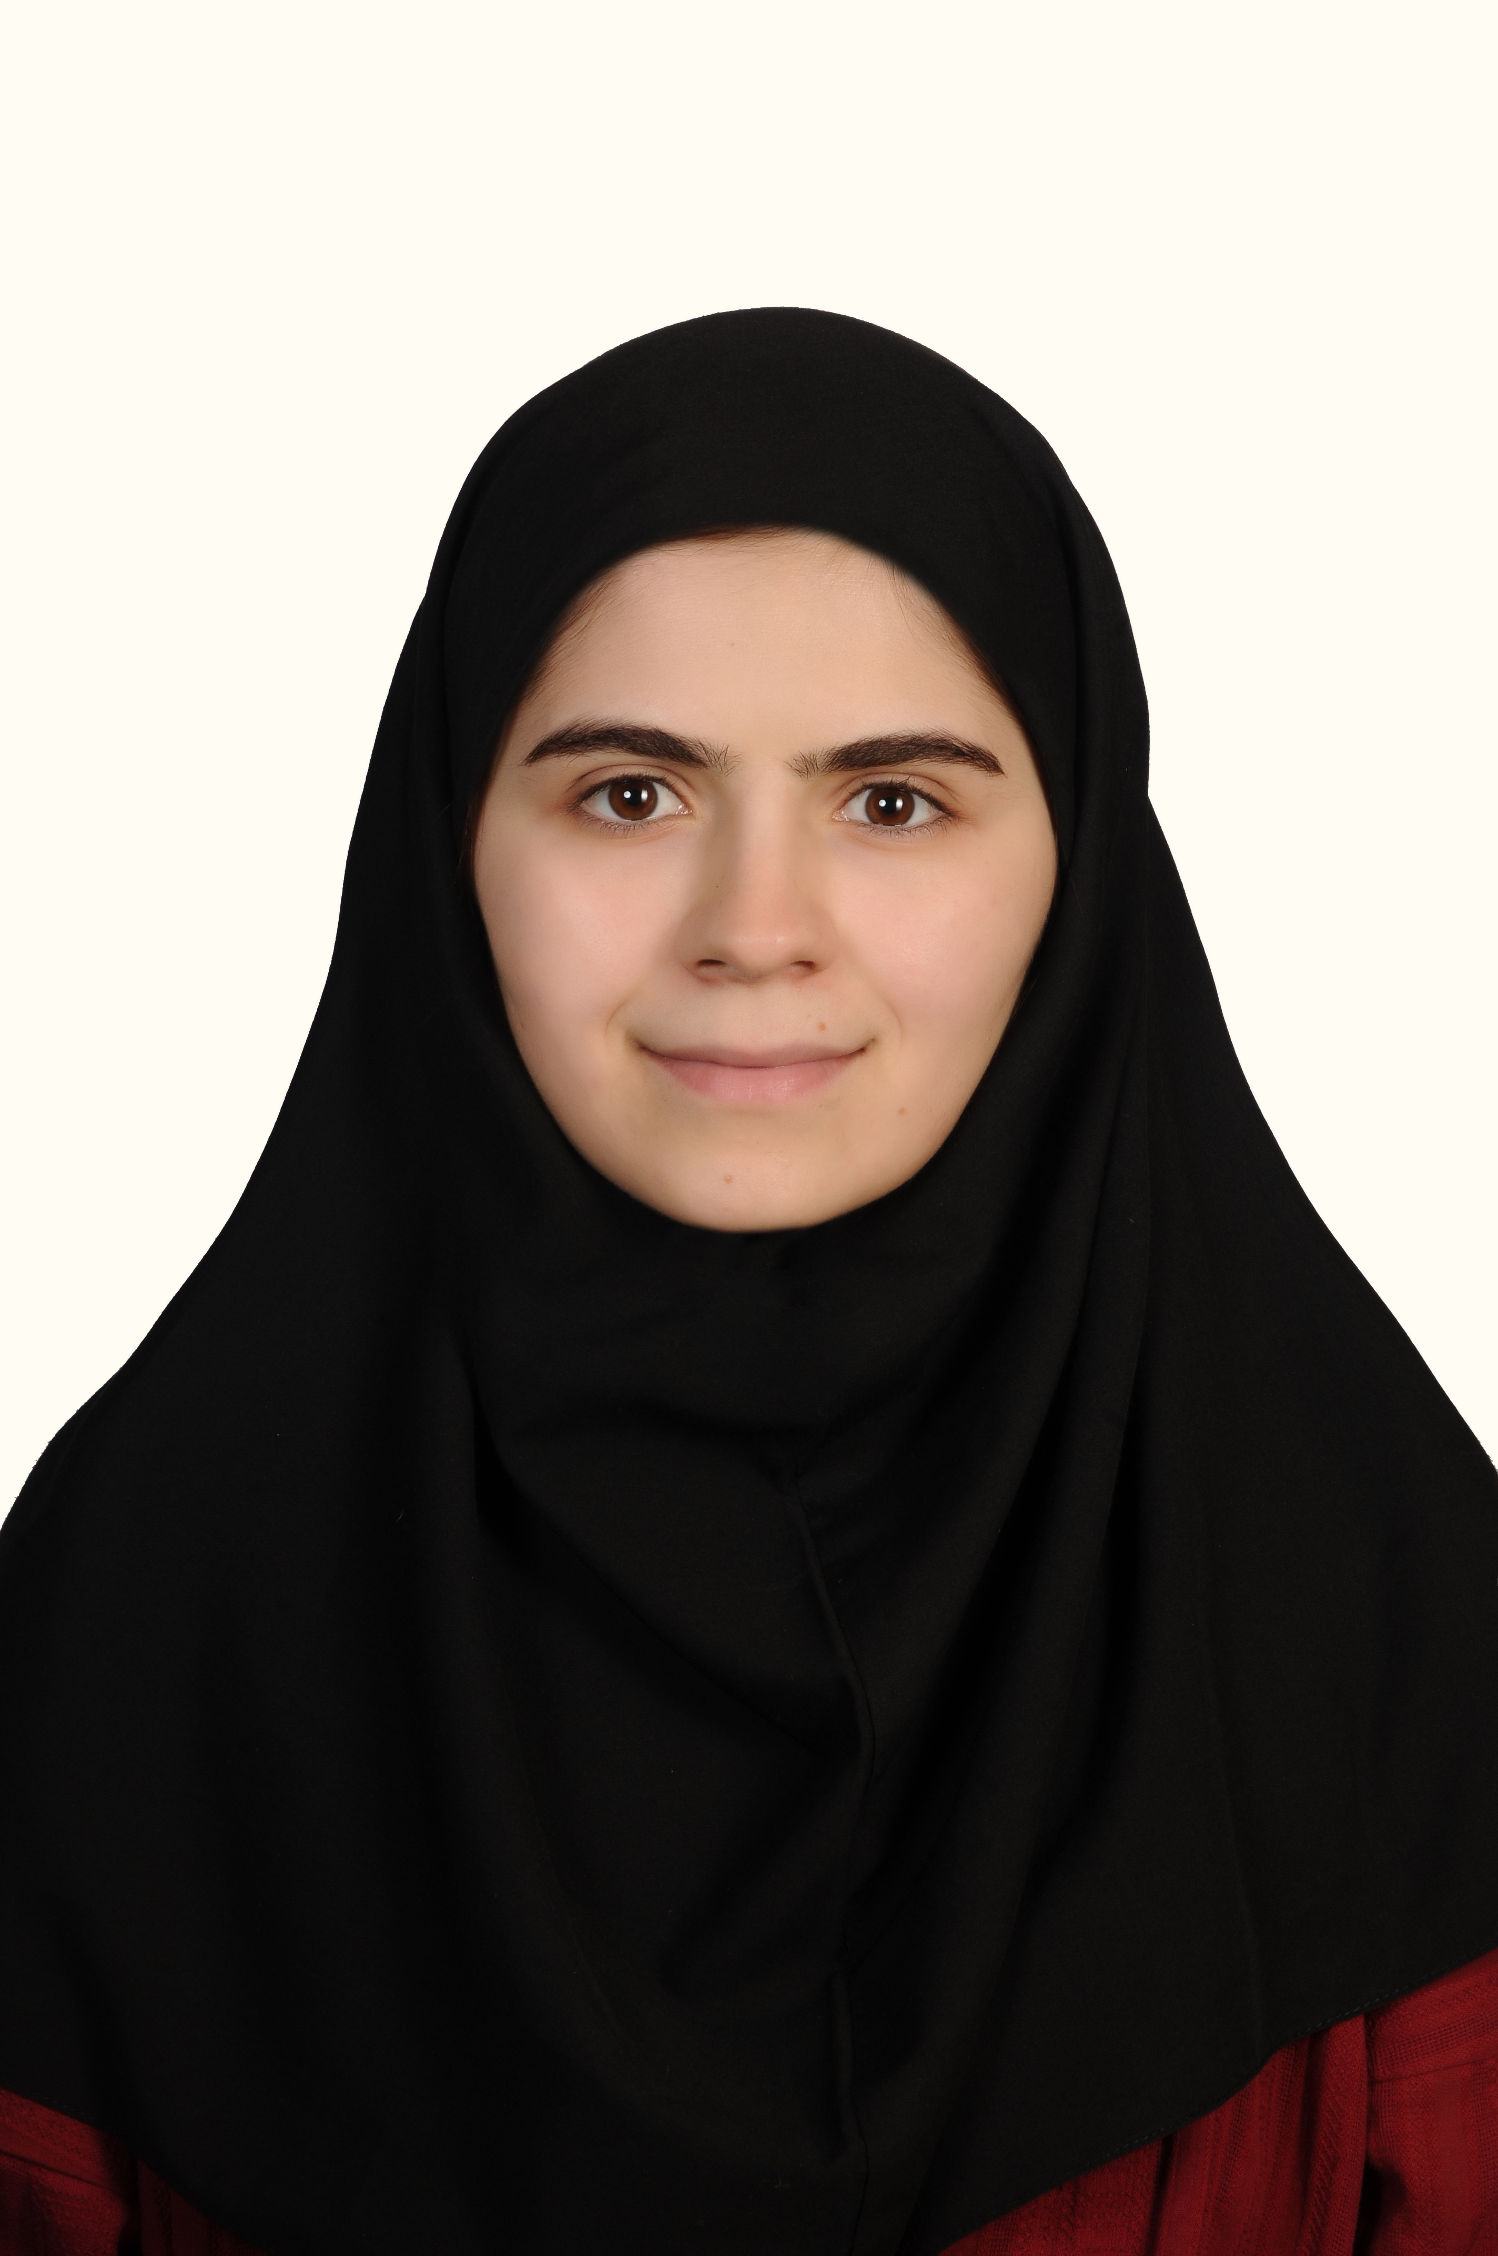

**NAME: Maryam Salehzadeh**

**DATE AND PLACE OF BIRTH:** 1995, Tehran-Iran

**E-mail:** mm.salehzadeh@gmail.com

**EDUCATION AND QUALIFICATION:**

**LONG-TERM TRAINING:**

**1.**Postgraduate student of Orthodontics, Hamadan University of Medical Sciences (2019-2022)

**2.** General Dentistry, Tehran University of Medical Sciences Tehran, IRAN (2013-2019)

**PUBLICATIONS:**

**1.** Mahdavi N, Aminishakib P, Zavarei M, Yazdani FB, **Salehzadeh M**. Adenoid Cystic Carcinoma and Polymorphus Adenocarcinoma: An Immunohistochemical Comparison. Iranian Journal of Science and Technology, Transactions A: Science. 2021 Dec;45:1895-904.

**2.** Mahmoudzadeh M, **Salehzadeh M**. Minimum Visit Management of a Localized Anterior Crossbite: A Report of a Dental Emergency Treatment During COVID-19 Pandemic. Avicenna Journal of Dental Research. 2022 Mar 29;14(1):44-6.

**3.** Shirdare M, Jabbari F, **Salehzadeh M**, Ziamajidi N, Nourian A, Heidarisasan S, Ghavimishamekh A, Taheri Azandariani M, Abbasalipourkabir R. Curcuma reduces kidney and liver damage induced by titanium dioxide nanoparticles in male Wistar rats. Avicenna Journal of Phytomedicine. 2022 Sep 1;12(5):537-47.

**4.** Mahmoudzadeh M, Farhadian M, Ahmadpour Y, **Salehzadeh M**, Evaluation of Smile arc influence on esthetic perception in relation to gingival display; a cross sectional study in Iranian population. Frontiers in the Dentistry 2022 (accepted, not published)

**5.** Soheilifar S, **Salehzadeh M**. High pull headgear orthopedic effects on vertical maillary excess and mandibular autorotation; report of three cases. Journal of Dentomaxillofacial Radiology, Pathology and Surgery. 2022;11(1):33-9.

**6.** Alijani S, Khamverdi Z, Miresmaeili AF, Khorshidi FM, **Salehzadeh M**. Effect of Dental Students’ Dressing on Dentist-Patient Relationship. Avicenna Journal of Dental Research. 2022 Nov 30.

**7.** Alijani S, Ghamari A, Kazemi-Saleh A, **Salehzadeh M**. Immediate autotransplantation of a mandibular premolar with complete roots to a fractured tooth site, using Platelet-rich fibrin in an orthodontic patient, report of a case. Dental Research Journal, 2022

**8.** Mollabashi V, Soleymani M, Arabestani MR, Farhadian M, Abbasalipourkabir R, **Salehzadeh M**. Evaluation of Nano TiO2 Modified Orthodontic Composite Effects on S. mutans Population and Enamel Demineralization in Fixed Orthodontic Patients; a Split Mouth Randomized Controlled Clinical Trial. Biological Trace Element Research. 2023 Jan 20:1-0.

9. Atefeh Maddah, Hiva Danesh,Parvin Ghasemi, Nasrin Ziamajidi, Maryam Salehzadeh, and Roghayeh Abbasalipourkabir. The Effect of Titanium Dioxide (TiO2) Nanoparticles on Oxidative Stress Status in the HCT116 Human Colon Cancer Cell Line. BioNanoSciences. 2023

**10.** **مریم صالح زاده**، رقیه عباسعلی پورکبیرره، پرهام نوروزی " استفاده از نانو ذرات در تشخیص و درمان سرطان سینه: یک مطالعه مروری" مجله علمی پژوهان 1393

**CONGRESS:**

**1-Salehzadeh Maryam** and Majid Mahmoudzadeh, “19th Annual Scientific Convention and 5th International Symposium of Iranian Association of Orthodontists 2022, Tehran, Iran.

**2**-**Salehzadeh Maryam** AND Mahdavi Nazanin,” malignant transformation in oral lichen planus, report of a case and review of literature”, the 7th meeting of the Iranian division of international academy of pathology, 2018 Tehran, Iran.

**3-Salehzadeh Maryam** and Mahdavi Nazanin,” report of a rare malignant tumor in oral mucosa”, National congress on clinical case reports, 2018, Tehran, Iran.

**4-Salehzadeh Maryam** and Kheirandish, Y “importance of radiographic findings in cleidocranial dysplasia” 8th Iranian oral and maxillofacial radiology congress, 2015,Tehran-Iran

**BOOKS:**

**1.** Dental pulp Stem cells, Panahandehshahraki A, Beshkar M, **Salehzadeh M,** Rouyanpajooh press,2020 (translation)

**2.** Contemporary treatment of dentofacial deformity, profit & white, Badiee M, …., **Salehzadeh M**, 2021, rouyanpajooh press (transaltion)

**۳.** نسرین فرهادیان،...،**مریم صالح زاده** و همکاران. درسنامه واحد مفصل گیجگاهی فکی. انتشارات دانشگاه علوم پزشکی همدان (تالیف)

**Reviews: (certificates will be attached)**

**1.** Journal of Dental Research Dental Clinics Dental Prospects (indexed in pubmed)

**2**. Avicenna journal of Dental Research